1. display a calender, that showing the date of today
2. Create a table with 7 columns, create table headings ‘Sunday’ to ‘Saturday’.
3. Create ‘previous’ and ‘next’ buttons to nagivate months and Year.

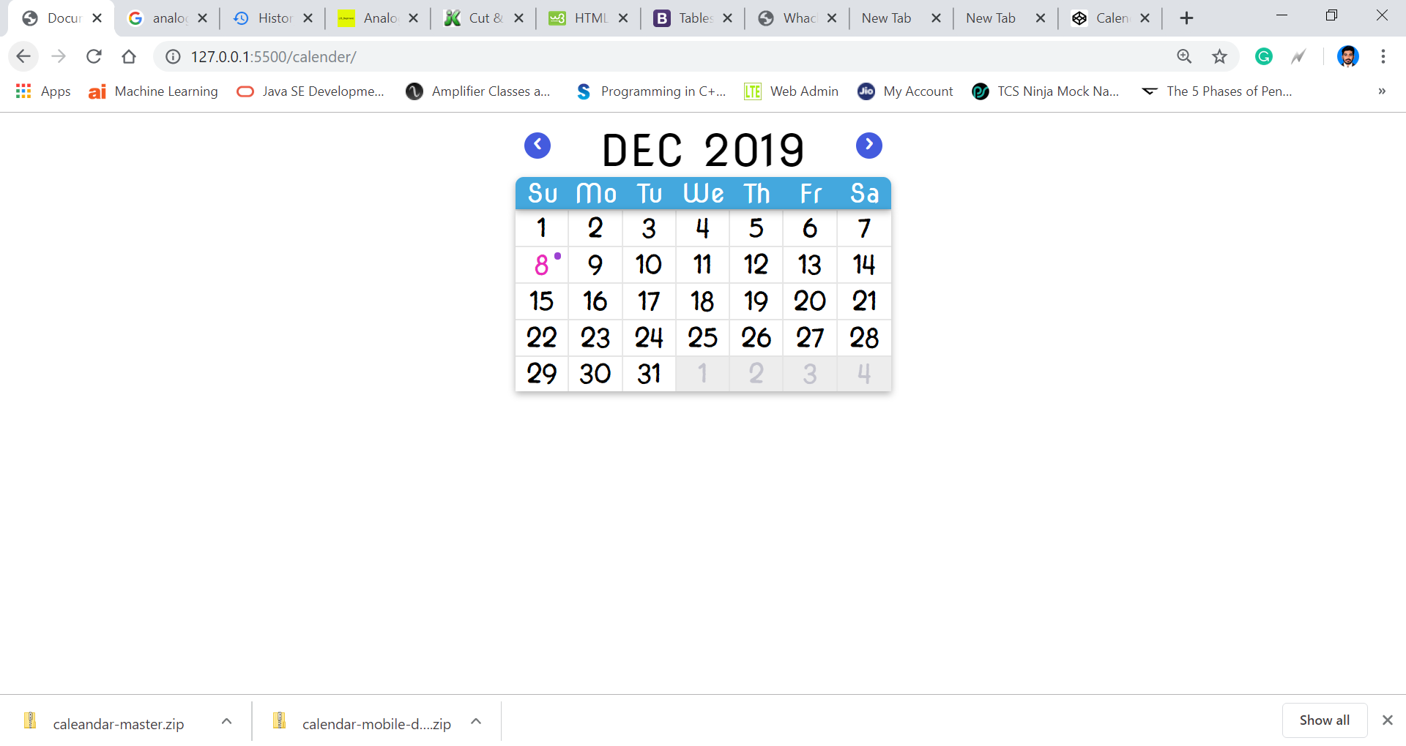

1. "Which day of the week was I born?

Write a function that calculates the day of the week for any particular date in the past or future. A typical application is to calculate the day of the week on which someone was born

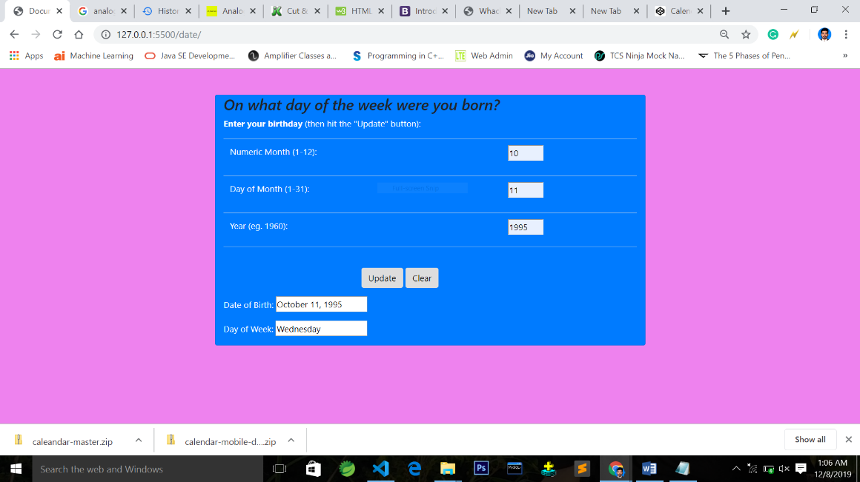

1. ­

a)Counts how long you've lived, in days + hours + minutes?

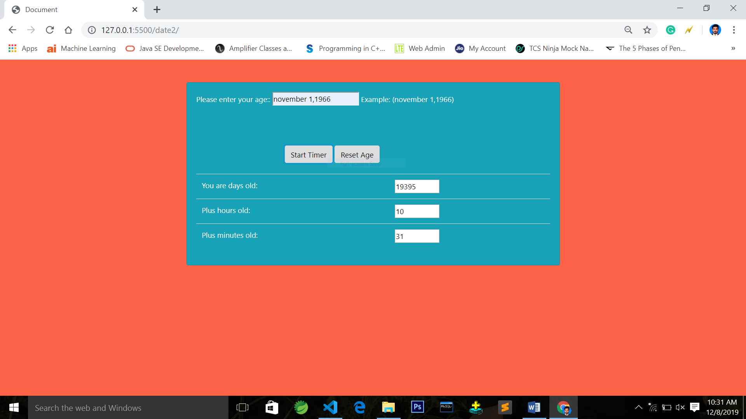

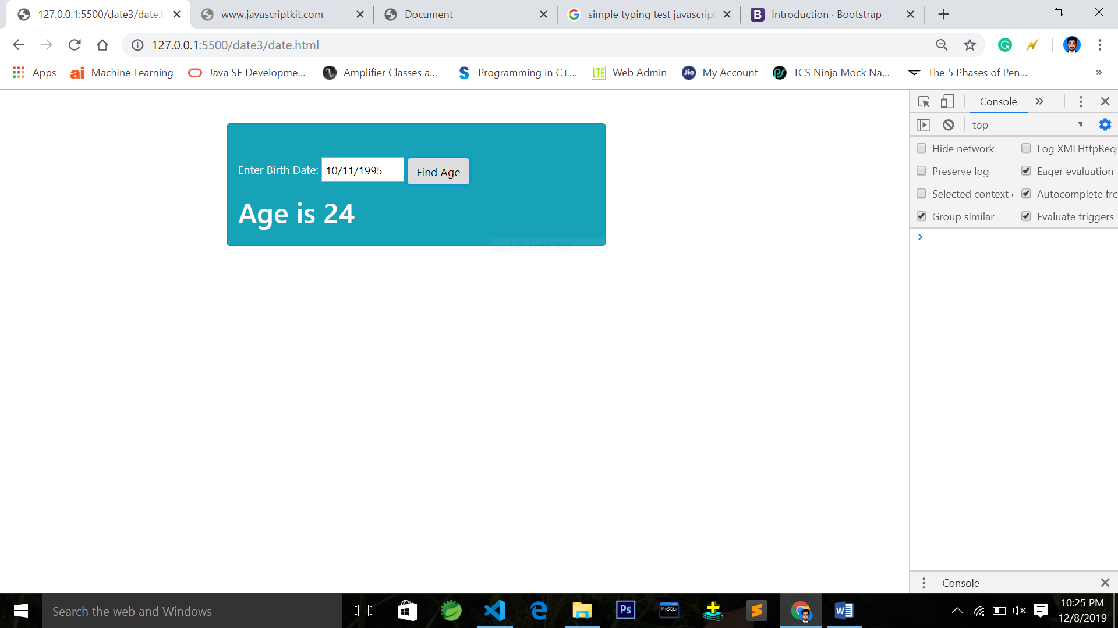b) Calculate age from given birth date

1. search and sort

a)create a array of items

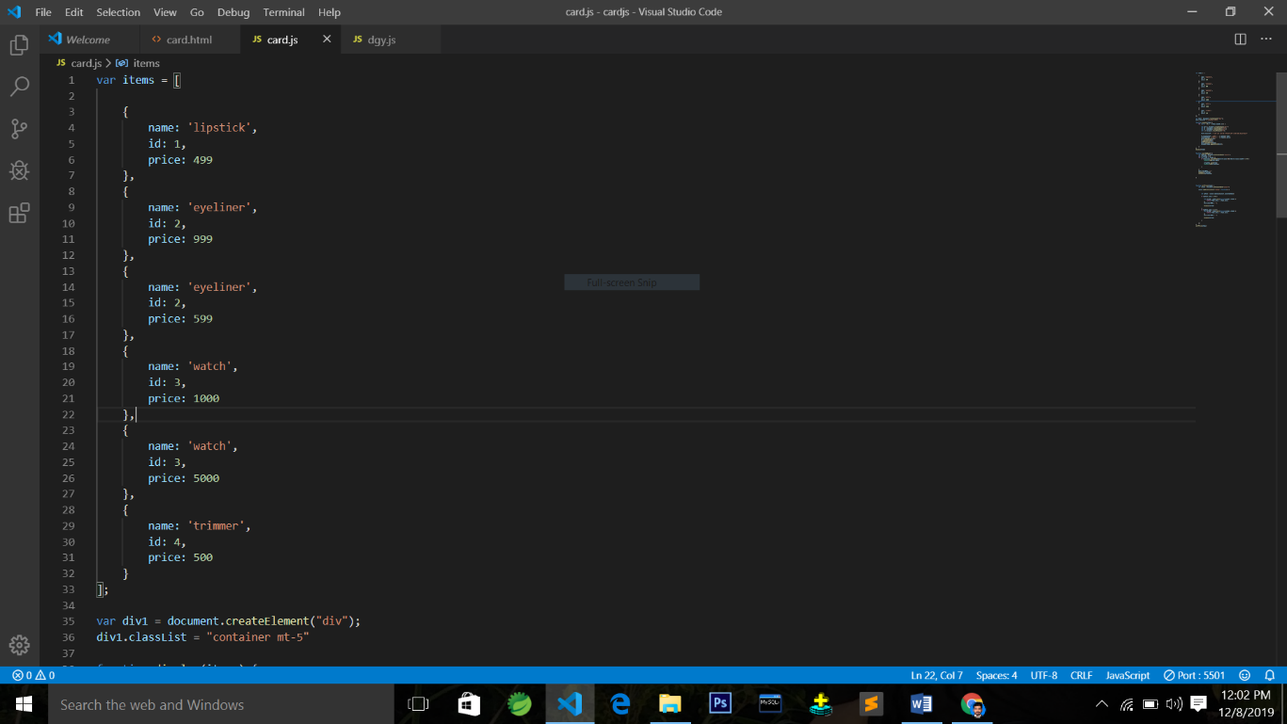

b)Display all items in web page

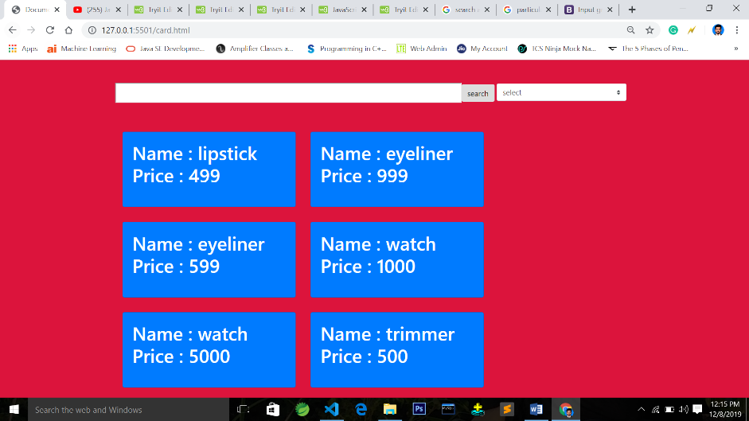

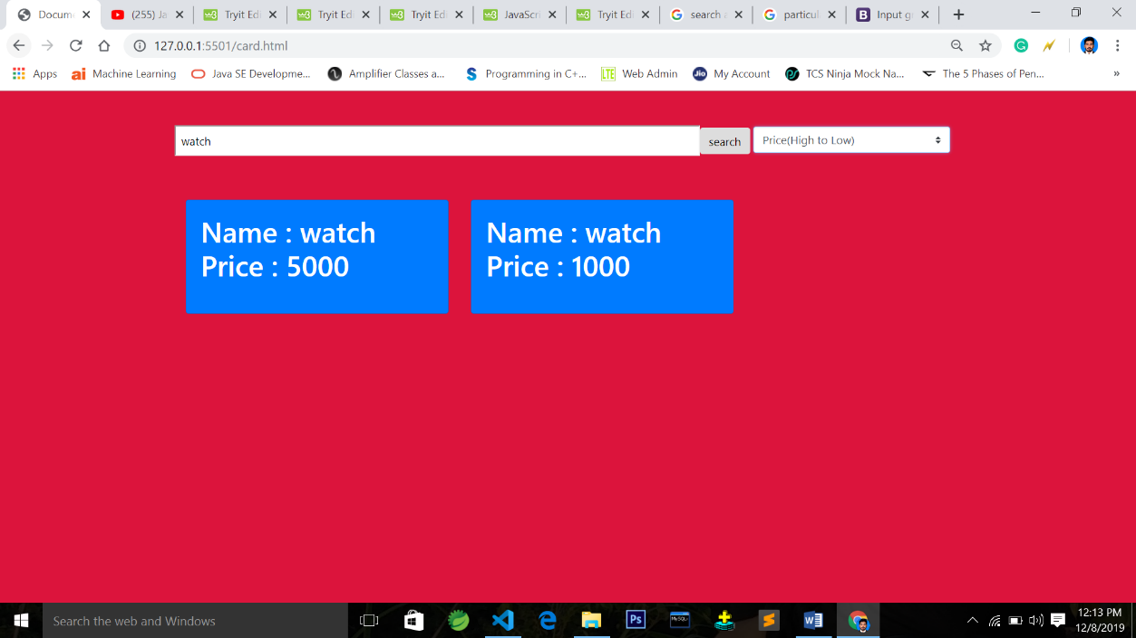c)search particular item and sort according to price (low-high) and price(high - low)

1. Analogue Clock Project

To create an analog clock using HTML5, CSS3 and JavaScript for website.

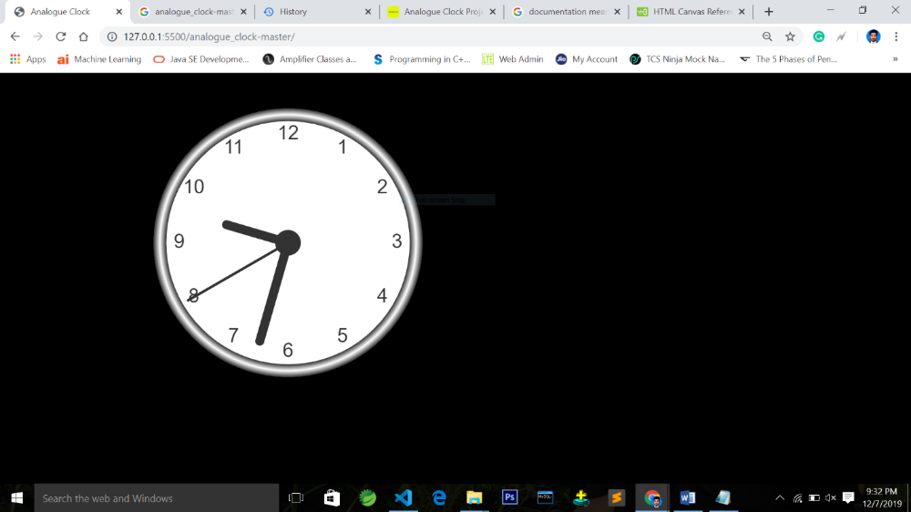

6) Disable text box on failure of 3 login attempts

